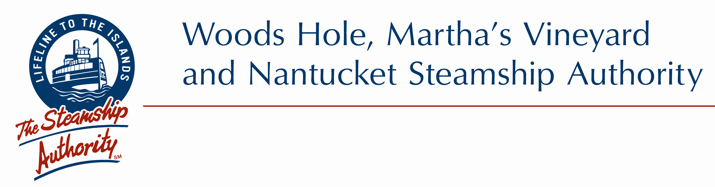

"BID NOTICE"

INVITATION FOR BIDS

DRY-DOCK AND OVERHAUL SERVICES FOR THE M/V SANKATY

CONTRACT NO. 04-2018

The Woods Hole, Martha’s Vineyard and Nantucket Steamship Authority will accept sealed bids for “Dry-dock and Overhaul Services for the M/V Sankaty” during regular business hours at the Steamship Authority's Procurement Office, located at its NEW FALMOUTH OFFICE LOCATION, 228 Palmer Avenue, Falmouth, MA 02540, 2nd Floor, Room 207, until 2:00 p.m. prevailing time, on Monday, November 19, 2018, at which time and place they will be publicly opened.

The Contractor shall be prepared to receive the M/V SANKATY at the Contractor’s venue on or about September 9, 2019 and commence work immediately thereafter and complete all work not later than December 19, 2019 at which time the vessel is to be delivered back to the Steamship Authority.

All Requests for the Specification and Drawing Package may be obtained by contacting the Steamship Authority's Procurement Office, telephone (508) 548-5011, extension 515 or email: pnickerson@steamshipauthority.com.

Each Bid must be accompanied by a bid deposit in the form of a bid bond, or cash, or a certified check on, or a treasurer's or cashier's check issued by, a responsible bank or trust company, payable to the "Woods Hole, Martha's Vineyard and Nantucket Steamship Authority" in the name of which the contract for the work is to be executed. The amount of such bid deposit shall be five percent (5%) of the TOTAL CONTRACT PRICE set forth in the bid.

The Steamship Authority reserves the right to reject any or all bids, to modify or amend with the consent of the bidder any bid prior to acceptance, and to waive any informality, all as the Authority in its sole judgment and discretion may deem to be in the public interest.

